

**Lab Terminal # 04**

**Submitted by:** Isha Eman

## **Reg #:** fa21-bcs-046

**Explain the input output of your mini compiler.**

* **Input:**
  + **Source Code File (.cs):** The input in mini-compiler is a file containing source code written C# language, which includes:
    - Integer Variable Declarations: int variableName = integerLiteral;
    - Assignment statements : variableName = expression;
    - Binary operations like +, -, *, /
    - Semicolons ; to end statements.
    - Comments in format //This is a comment
    - Note that, compiler does not support boolean type, function call, loop statement or conditional statements yet.
* **Output:**
  + **Intermediate Code (Text Output):** The final output is a list of assembly-like instructions that represent the low-level actions your program will perform. These instructions are not machine code for any actual processor but more of an intermediate representation. The instructions might include:
    - load value: Loads a value
    - store variableName: Stores a value into variable
    - add, sub, mul, div: Arithmetic operations
  + **Error Messages:** If there are any errors during any of the stages (lexing, parsing, semantic analysis), the compiler will print those messages to the console.

**Case 1:**

Input

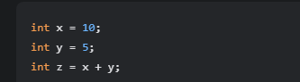

Output

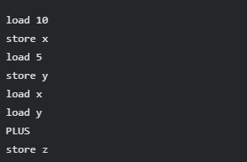

**Case 2:-**

Input

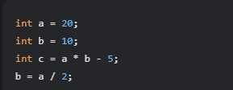

Output

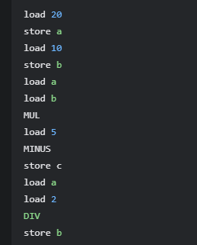

**Case 3:**

Input



Output

